Bash scripting

Output to screen
I created a directory named mujju/scripts to store all my script tasks. Then, I checked the present working directory using pwd, opened helloworld.bash with vi and added the script. After that, I gave it chmod 755 permissions, executed it using ./helloworld.bash, and finally used the cat command to view the script.
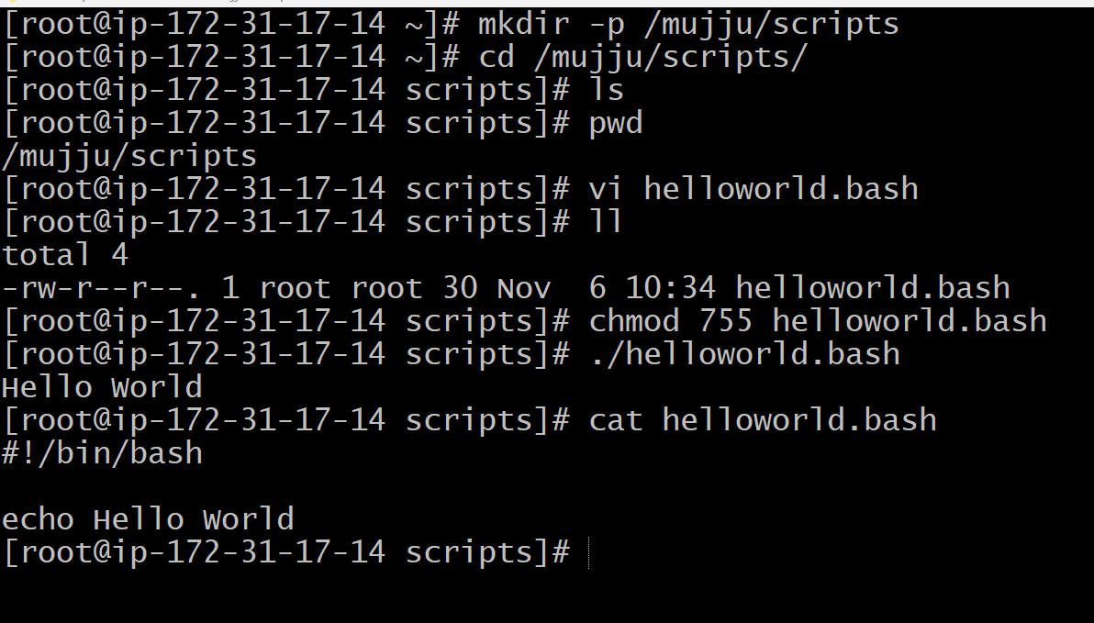

- Defining commands
In this I have added comments and commands .
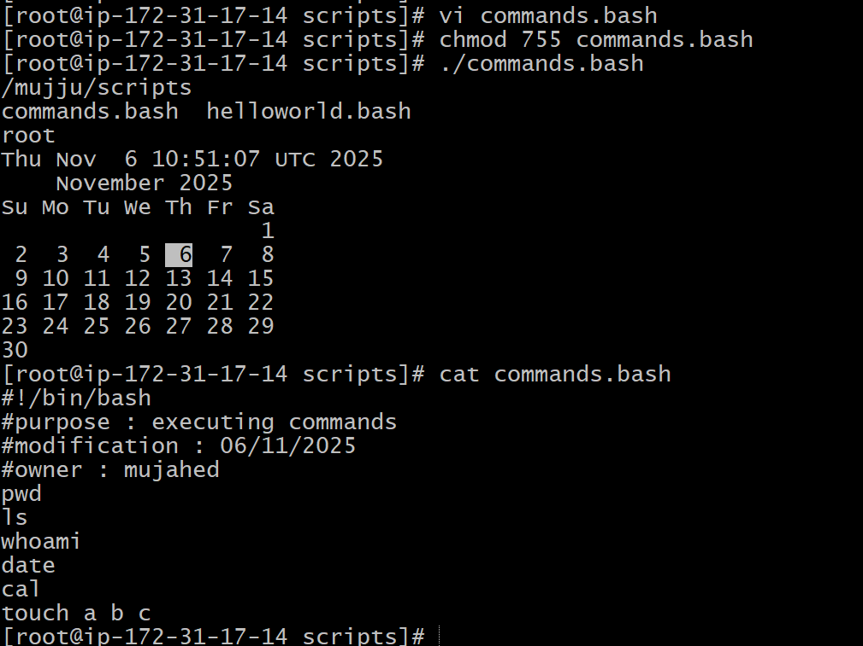

- Admin script

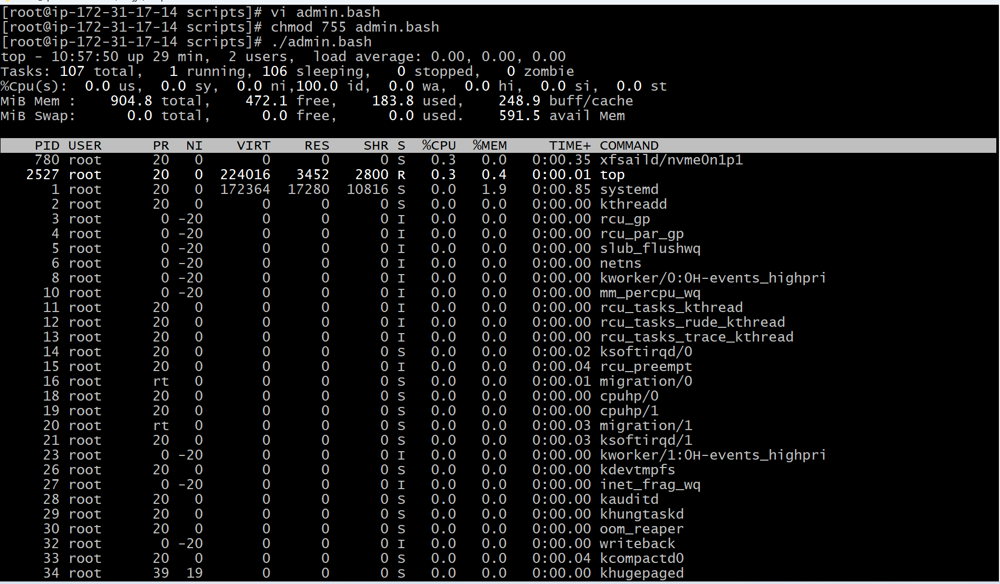
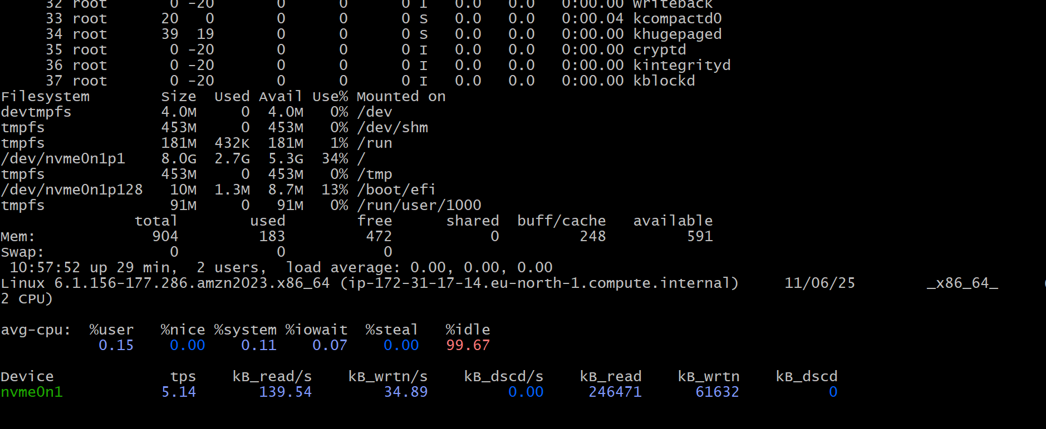

- Defining variables

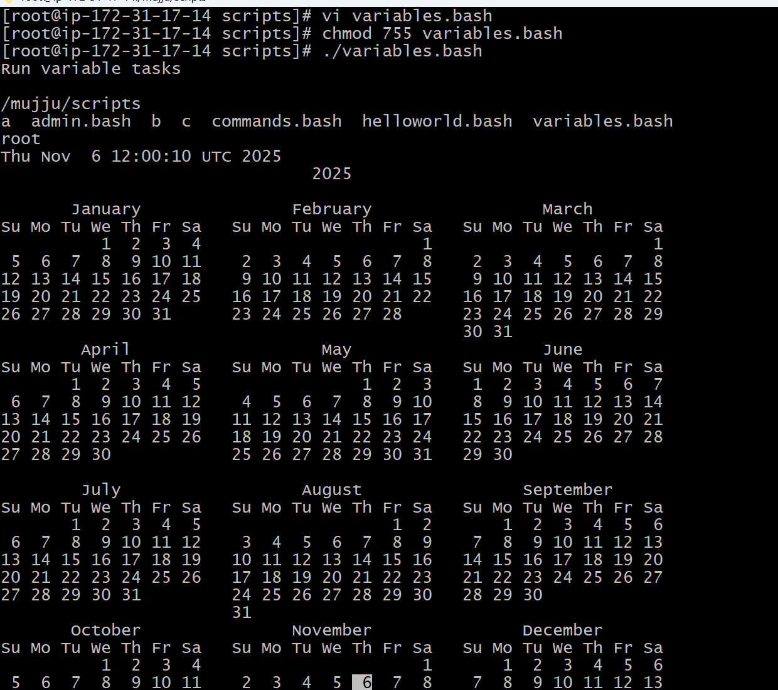

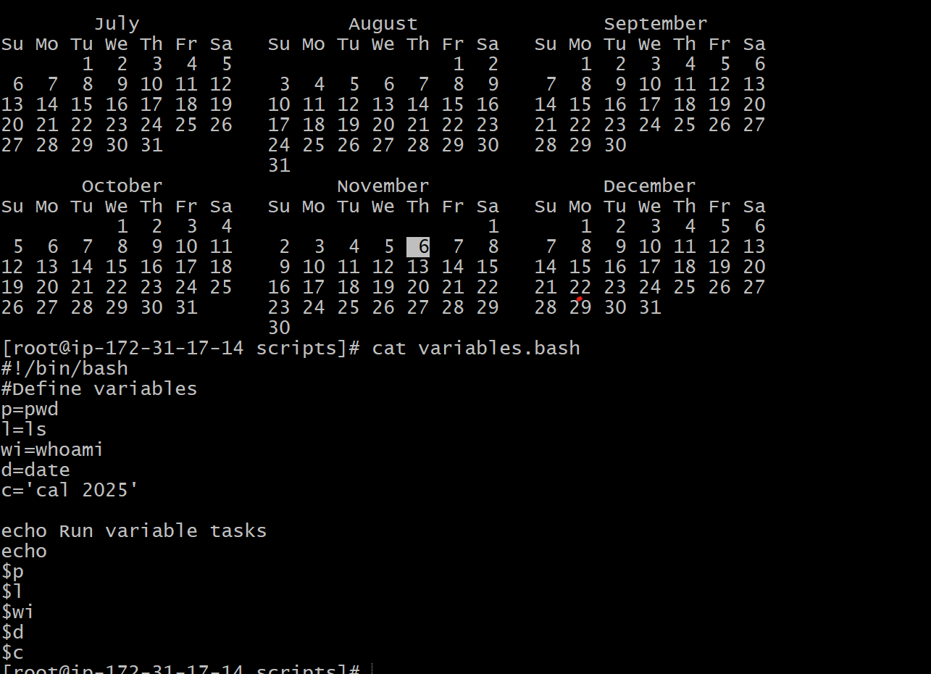

- Input/Output script
Read – To take command from user
Echo – To print the output
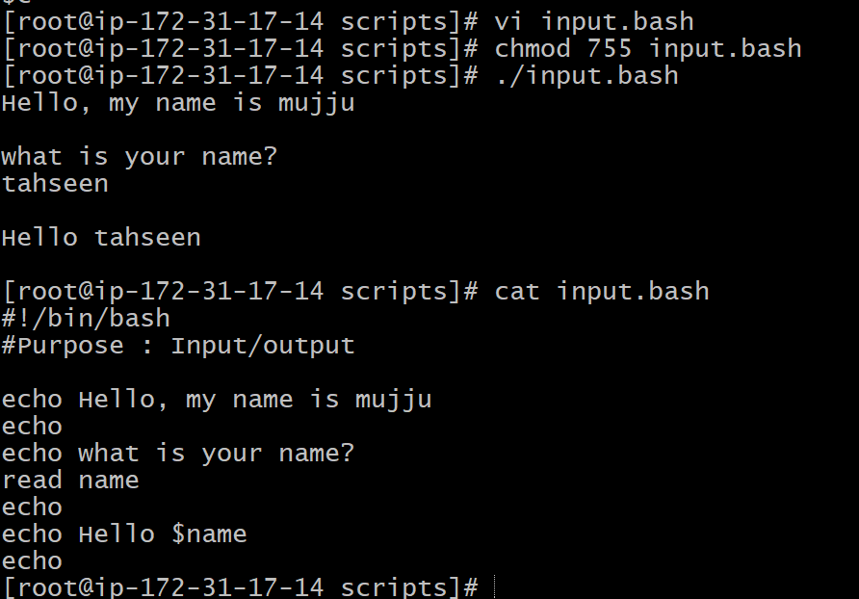

- Display Hostname
